

**UNIVERSITY OF PETROLEUM & ENERGY STUDIES**

**Dehradun**

**CONTINOUS INTEGRATION**

**AND**

**CONTINOUS DELIVERY**

**Experiment**

**Name: Harshil BHardwaj**

**Course: B. TECH CSE DevOps (2018-22)**

**Roll no.: R171218045**

**Sapid: 500068580**

**Experiment-7**

**Create pipeline using Blue Ocean Plugin**

**Step-1:** Start and login to Jenkins

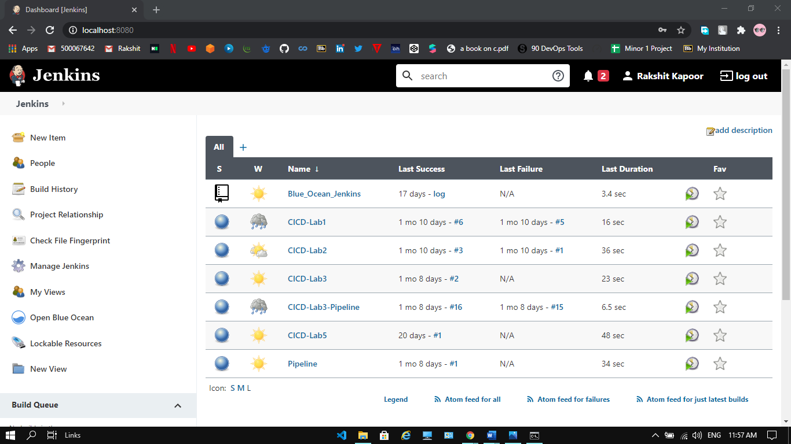

**Step-2:** Install Blue Ocean Plugin and will be able to see in on the dashboard.

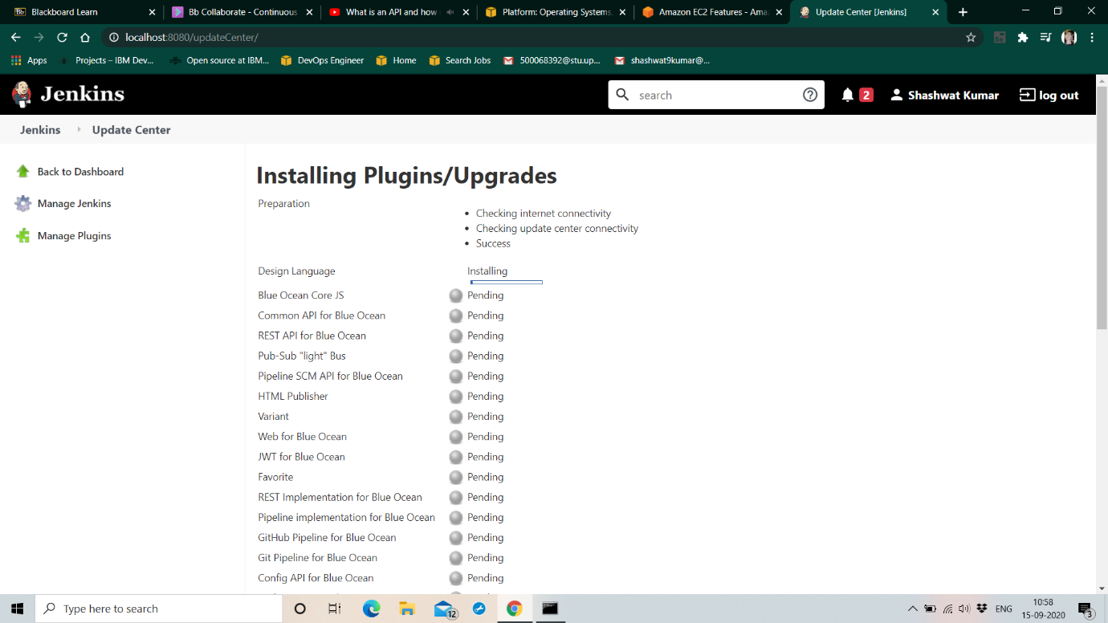

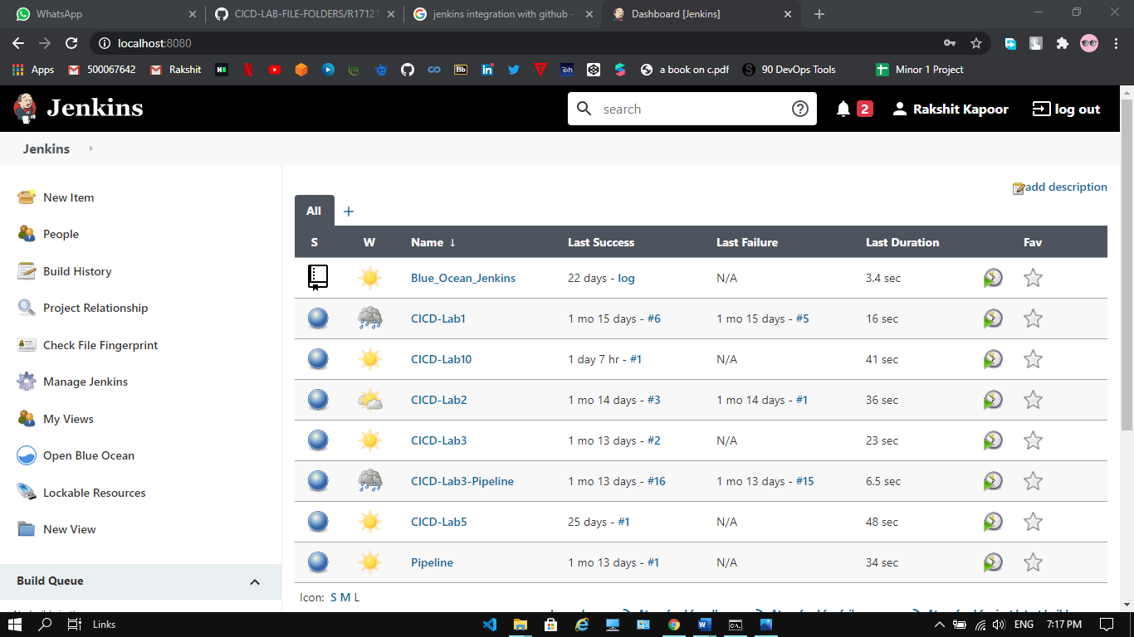

**Step-3:** Click on Open Blue Ocean and create new pipeline. Connect it with GitHub. Choose the repository and click on Create pipeline.

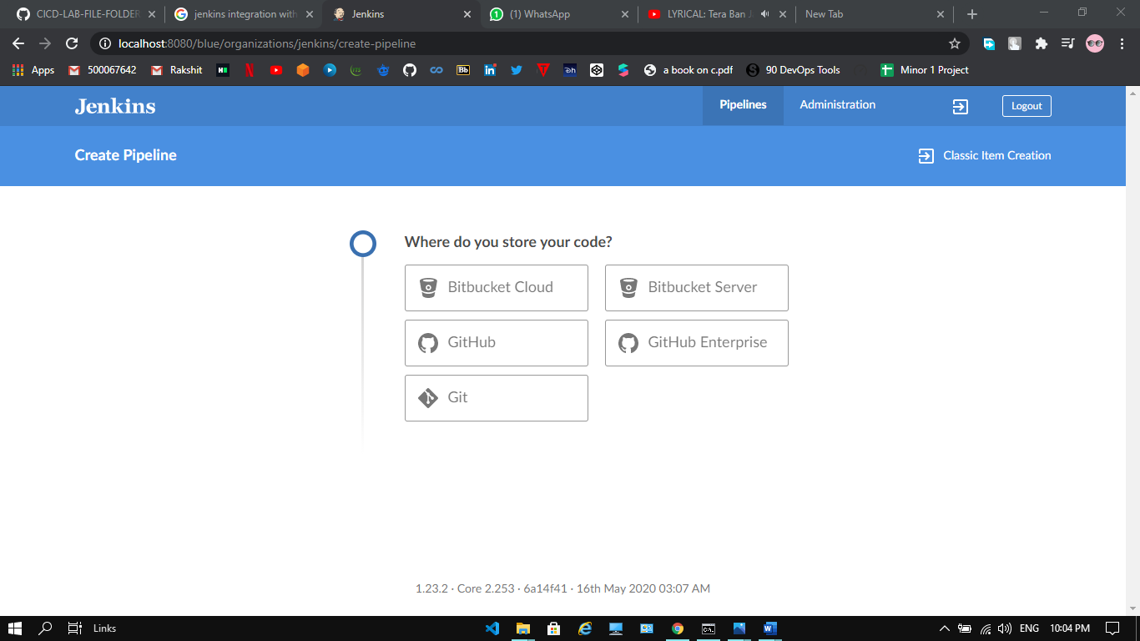

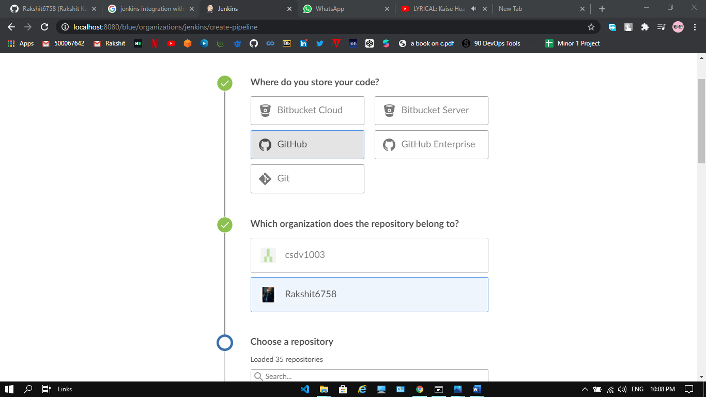

**Step-4:** Pipeline will be created.

